Guidance and Support for the Digital Account

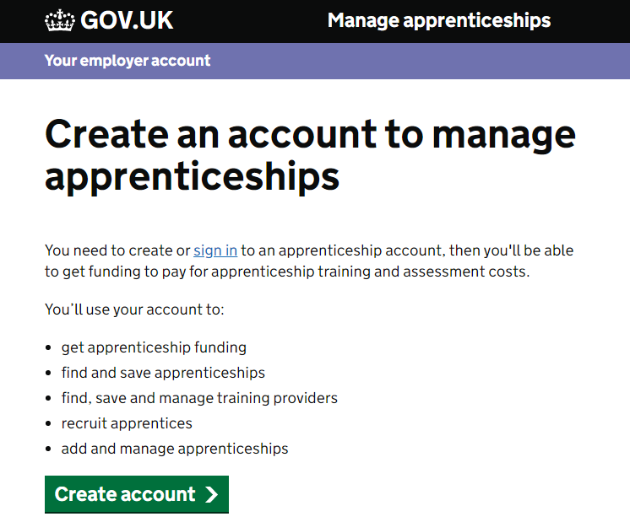**How do I set up an account?**

## Please click [**here**](https://accounts.manage-apprenticeships.service.gov.uk/service/index) to set up your account with the National Apprenticeship Service.

You will need Colchester Institute’s **UKPRN Number** which is **10001535**.

## Please note if you haven’t set up the digital account yet, then you will require your PAYE number and Accounts

Office Reference Number (*your accountant should be able to support with this information*).

# Where can I find my Accounts Office Reference Number?

## Your Accounts Office Reference Number will be shown on the letter you received from HMRC when you first registered as an employer. It is also on a vast majority of the correspondence received from HMRC.

The Accounts Office Reference Number is the reference used by an Employer when making payments to HMRC and is often mistaken for the Employer Reference Number (ERN). This is a common misunderstanding as the numbers are similar and often appear together on relevant documents such as the P45, P60, P11/D and on payslips.

# How is the Apprenticeship Funded?

Full government funding is available for an apprentice aged between 16-18 years old and where the employer employs less than 50 employees. Full funding is also available for apprentices aged 19 to 24 who have either been in care or has an education health care plan.

An employer contribution fee will be required for:

* Non-levy paying employers recruiting an apprentice aged 19 or over
* Non-levy paying employers who employ more than 50 employees and recruit a 16-18 year old apprentice

**The Next Steps...**

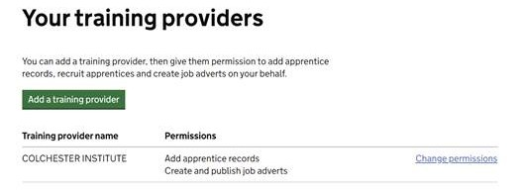

**1.**

Once logged in, you will be required to accept the ESFA agreement, you will need to accept this before you can proceed to the next step.

**2.**

From the homepage you need to scroll down and select, **‘Your Training Providers’**

**3.**

Select the green button, called **‘Add a Training Provider’ *(See image below)***

**4.**

You will now be requested to enter the UK PRN Number for Colchester

Institute this is: **10001535**.

**5.**

Once you have selected Colchester Institute, you will need to set the training provider permissions.

**6.**

Please also remember to set the permissions for Colchester Institute to advertise on your behalf, this will say: Create and Publish Job Adverts.

**7.**

Colchester Institute will then be able to advertise on your behalf and submit apprentice details once enrolled.

**8.**

You will be required to approve your apprentices details, once enrolled –

you will receive notification at this stage from Colchester Institute.

**To complete steps 2 - 6 please scroll down to the bottom of the home page to locate ‘Your Training Providers’**

# 